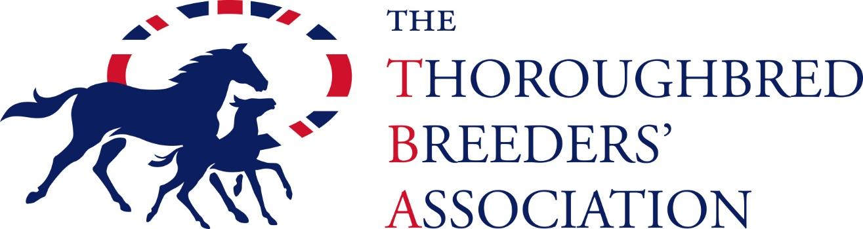

TERMS & CONDITIONS – RACECOURSE BADGE SCHEME FOR BREEDERS (RBSB)
PLEASE NOTE THIS BENEFIT PROVIDES COMPLIMENTARY BADGE(S) WHEN A HORSE YOU HAVE BRED IS DECLARED TO RUN AND IS FOR THE DURATION OF YOUR TBA MEMBERSHIP ONLY
Data protection: by completing the application form you are consenting to the information being shared and used only for the purpose of the scheme by the TBA, the RCA and Weatherbys and to being contacted with news and amendments of the scheme. Your information will not be shared with any third parties. Any communication you receive as a result of completing this form will be for the sole purpose of the scheme.
- Upon receipt of this application form your breeding details will be sent to the RBSB Helpdesk for processing, following which you will receive confirmation via email on how to log in. Please note that plastic swipe cards are no longer being issued.
- The RBSB scheme is administered by the TBA and general enquiries should be emailed to alix.jones@thetba.co.uk or by phone on 01638661321.
- Applications will only be accepted by submitting the form to the TBA accompanied by a photograph. Please send this to alix.jones@thetba.co.uk. If no photograph is attached please take additional identification with you to ALL racecourses.
- Membership of the RBSB entitles complimentary access to the racecourse for the fixture list on to the TBA website www.thetba.co.uk to ensure the track is taking part in the scheme and how many badges are available.
- RBSB badges will not apply in addition to the standard allocation of badges given to owners with a runner on a particular day.
- On-course bookmakers are not eligible to apply.
- The TBA/RCA reserves the right to alter, amend or add to the conditions of membership at any time.

