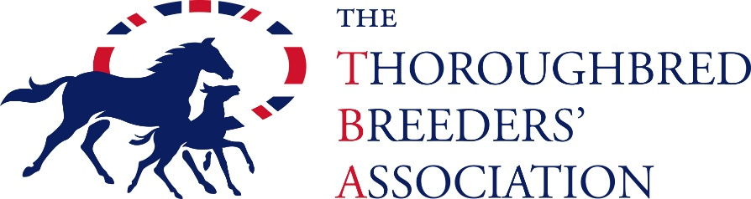
TBA Stud Employee Award 2026 – Key Terms and Conditions
- Nominations may be made by an employer, line manager, colleague or client (excluding family members) and must be countersigned by the Stud Owner/Manager.
- The employer must be a current member of the TBA.
- Awards may recognise a willing attitude to learning and taking on new responsibilities, Promise as a future leader, excellence in their day-to-day role, exceptional performance in a specific situation or a team player who motivates or acts as a mentor to others.
- The nomination period will run from March to May 2026.
- Shortlisted nominees will take part in a telephone interview shortly after the closing date. Nominators will be notified before interviews begin.
- The overall winner will be presented with the award at the TBA Flat Breeders’ Awards Evening.

